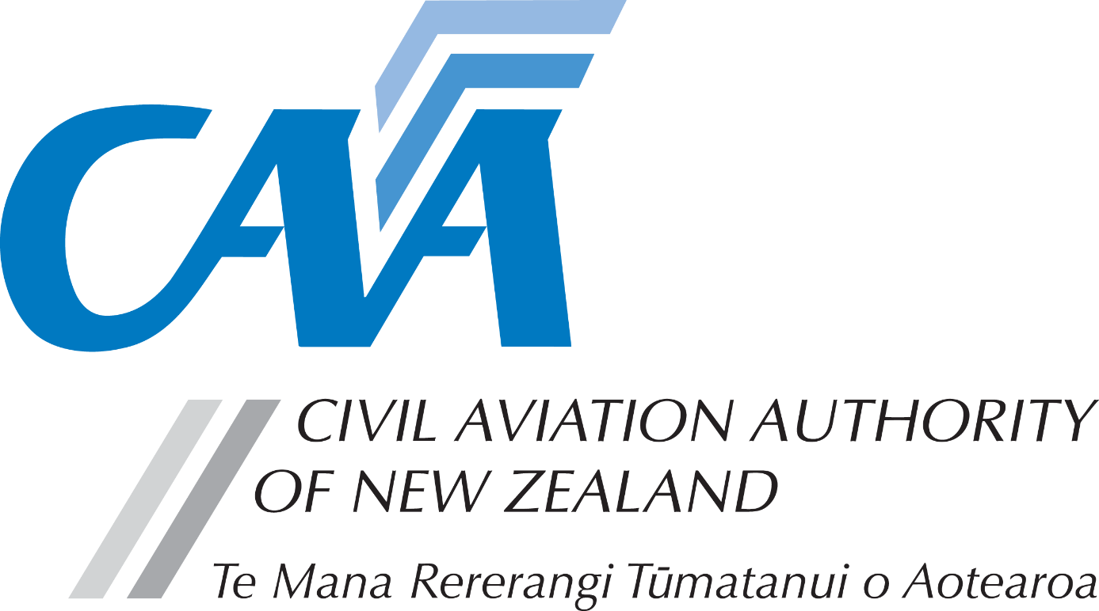
Part 66 aircraft maintenance engineer licence – maintenance approval

Note to applicants:
The appropriate completed fit and proper person form (CAA 24FPP or 24FPPDEC) is required with this application. Refer to the CAA website for guidance on the appropriate form to be used.
- Personal details
CAA participant number (if known) |  |  |  |  |  |  | Date of birth (dd/mm/yyyy)
Title (Mr/Mrs/Ms/Miss) |  |  |  | Last name
Given name(s)
Address for service – The Civil Aviation Act 2023, section 73, requires applicants to provide an address for service in New Zealand (i.e. a physical address) and to promptly notify the Director of any changes.
Phone |  |  |  | Mobile
Email
Postal address (if different from address for service)
Phone |  |  |  | Mobile
Email
- Maintenance approval
Application for | Maintenance Approval Issue |  |  |  | ☐ |  | Maintenance Approval Renewal |  |  | ☐ | Maintenance Approval Amendment |  |  | ☐
1. Please give details of the maintenance to be performed

2. Detail the associated tasks required to perform the maintenance requested

3. Specify fully the aircraft or component and registration etc

4. Please give details of employer or company name the maintenance task is performed for.

 | Experience log completed |  |  |  |  |  |  | Approval required for period
 | Yes | ☐ | No | ☐ |  |  |  | From |  |  |  | To
- Justification
Please offer details to justify the maintenance task being applied for.

- Experience log
Detail experience relevant to the maintenance privileges you are applying for.

Date from | Date to | Aircraft or Component | Experience details (Concise accurate statements – print clearly)

- Fees & payment details

- Please pay online at https://www.aviation.govt.nz/online-payment and attach the receipt that will be emailed to you.
- Unless the full fees are paid and receipt is attached, applications will not be processed.
- For information relating to fees, refer to the Civil Aviation Charges Regulations (No 2) 1991.
Payment details
Total fees
Receipt number
- Declaration
The provision of false information or failure to disclose information relevant to the grant or holding of an aviation document constitutes an offence under sections 107 and 362, respectively, of the Civil Aviation Act 2023, and is subject, in the case of an individual, to imprisonment for a term not exceeding 12 months or to a fine not exceeding $30,000, or both. | I declare that to the best of my knowledge and belief the statements made and the information supplied in this application and the attachments are complete and correct.  Consent to disclosure & collection  I authorise the collection by the Director of Civil Aviation or his delegate (hereinafter referred to as "the Director") from, and the disclosure to the Director by, any person, organisation or government department of any details of my knowledge & compliance with transport safety regulatory requirements.  I authorise the Director to use, and disclose, the information obtained about me for any purpose under the Civil Aviation Act 2023, or other such purpose permitted by law.
 | Applicant’s Signature |  | Date
- Applicant’s checklist
Please ensure all documents are enclosed. Applications which are incomplete or lacking any required documents will be returned. |  | Yes | N/A
 | - Appropriate fit and proper person form (24FPP or 24FPPDEC) | ☐
 | - Copy of Practical Training Record | ☐ | ☐
 | - Copies of relevant course certificates, or examination certificates | ☐ | ☐
 | - Payment receipt | ☐

Submit the completed application to either:
Email: lic.applications@caa.govt.nz
Post: Licensing and Standards, Civil Aviation Authority, PO Box 3555, Wellington 6140, New Zealand

