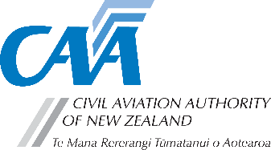
Request for Vector subscription for non-licensed aviation participants
The CAA is keen to deliver safety messages to all aviation participants. Most aviation licence or certificate holders will automatically be subscribed to Vector magazine, but some participants aren’t automatically added to the mailing list.
If you’re participating in aviation in one of the following ways, the CAA can offer you a free subscription to the printed edition of Vector magazine:
- holder of a pilot or parachutist certificate issued by a CAR Part 149 certificated organisation
- unmanned aircraft flyer (such as drone or model aircraft)
- Young Eagle, Air Cadet, or member of Youth Glide New Zealand.
Complete this form and email it to education@caa.govt.nz.
Note: If you wish to receive only the digital version of Vector magazine, go to aviation.govt.nz/subscribe to sign up for email notifications.

Application form

Title
First name(s)
Surname
Address
City
Postcode |  | Phone
Email
Do you have a CAA participant number (even if not current?) |  |  | Yes No
CAA participant number (if known) |  | Date of birth
What pilot certificate do you hold, or aviation activity do you participate in?
Drone Glider Microlight Hang glider/paraglider
Model aircraft Parachutist Young Eagle Other (specify)

