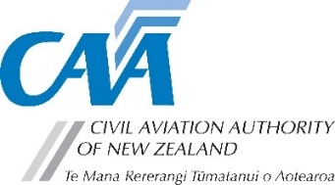
Part 39 application for alternate means of compliance

Instructions: | FOR CAA USE ONLY
- Submit your completed application to certification@caa.govt.nz | AMOC No.:
- This application is required by Civil Aviation Rule 39.53(a) and (b), but is not required for the application of a 10% latitude on a repetitive inspection under Civil Aviation Rule 39.55(d).
- The CAA standard hourly charge applies. See Fees, Levies, and Charges for more information.

- Application detail
Date:
Aircraft type: |  |  | Component:
Registration: |  |  | Part No & Serial No.:
Airworthiness Directive reference:
Select the appropriate box: |  | ☐ Alternative means of compliance |  | ☐ Adjustment of compliance time
Period of validity:
Proposed means of compliance: (should demonstrate equivalent level of safety)

- Requester details
Full name: |  | CAA participant No.:
Email: |  | Phone:

- Invoice details
Full name: |  | CAA participant No.:
Email: |  | Phone:
Purchase order No.:

FOR CAA USE ONLY
Recommendations or remarks (as required):
Full name: |  |  | Position:
Signature: |  |  | Date:
AMOC granted: | ☐ as requested | ☐ subject to the following conditions*
*conditions:
Full name: |  |  | Position:
Signature: |  |  | Date:
Note: AMOC number to be quoted in aircraft logbook

